## Student Goal Setting:

*How to Guide your Students to Maximum Success as you Climb the Six Exceptional Systems Staircase*



**Laura D’Acquisto**

**Los Peñasquitos Elementary**

**laura@NoExcusesU.com**

***“A goal without a plan is just a wish” -Antonie de Saint-Exupery***

**Comparing Assessments “Of” and “For” Learning**

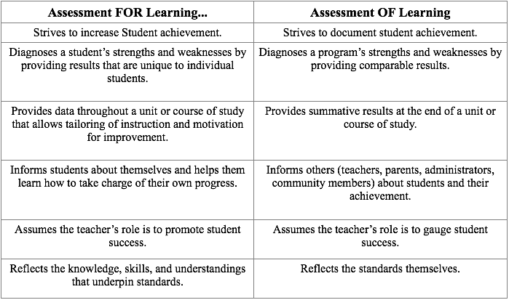

Portions from: Stiggins, R. (2002) Assessment Crisis: the absence of Assessment for Learning. Phi Delta Kappan, 83. p. 758

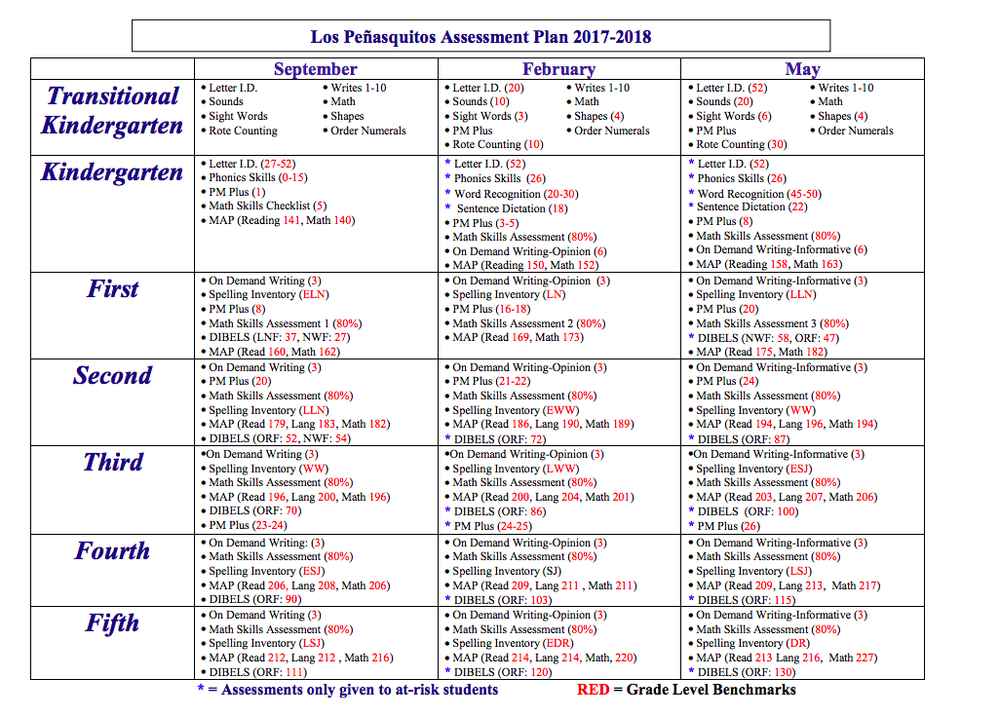

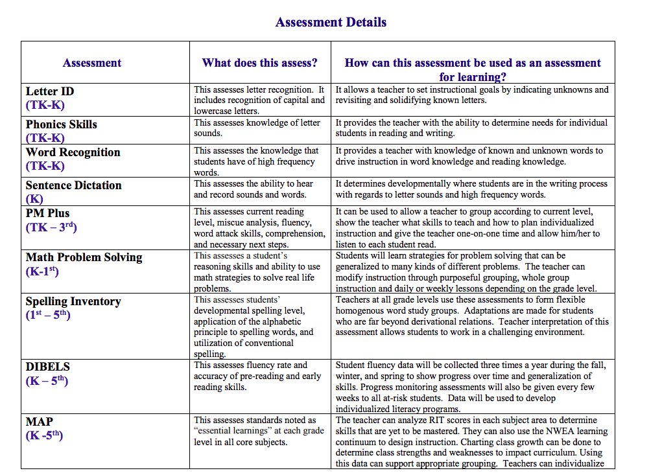

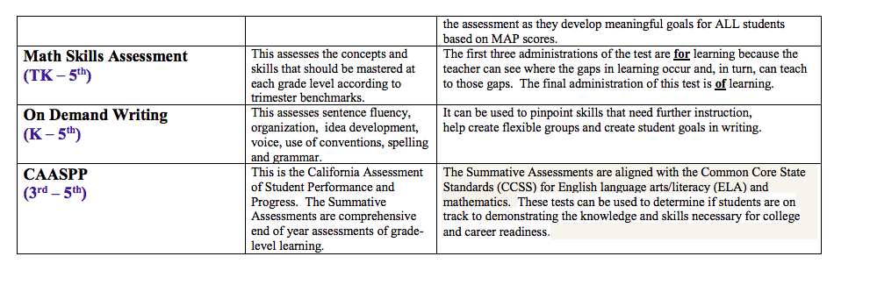

Assessment Details

|  |  |  |
| --- | --- | --- |
| ***Assessment*** | ***What does it assess?*** | ***How could this assessment be used “for” learning?*** |
|  |  |  |
|  |  |  |
|  |  |  |
|  |  |  |
|  |  |  |

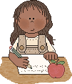 **____________________’s**

Student Goal Planning   
with MAPs: Reading

|  |  |  |  |  |
| --- | --- | --- | --- | --- |
| Reading | Fall Score | Winter Score | Spring Score | What is Measured |
| Overall Reading Score |  |  |  |  |
| Lexile Score |  |  |  |  |
| Word Analysis and Vocabulary |  |  |  | I use many different ways to figure out words I don’t know, such as word families, context clues, prefixes, suffixes, synonyms, antonyms, and homophones. |
| Literal Comprehension |  |  |  | I can answer questions by finding my answer in the reading passage. I can find the main idea in non-fiction reading. I can find problems and solutions in stories. I can follow instructions that have more than one step. |
| Interpretive Comprehension |  |  |  | I make predictions before, during, and after reading. I can make inferences that help me to understand what I’m reading and can recognize cause-effect relationships. I summarize information from different written materials. I understand fact and opinion. |
| Literary Response and Analysis |  |  |  | I can identify the characters, settings, plots, and lessons learned in my reading. I know how books are different (fiction, non-fiction, poetry, etc.) I can tell what a character is like by what the author says and what the illustrator draws. I can tell who the narrator is when I’m reading. |
| Time |  |  |  | sc1cl38a |

**____________________’s**

**MAP Reflection Sheet for Reading**

1. How did you feel when you were taking the test?



2. Did your score go up or down?

Why? ___________________________________________

1. What was your **highest** area? Put a on your goal sheet.

* Phonological Awareness
* Phonics
* Concepts of Print
* Vocabulary and Word Structure
* Comprehension
* Writing

4. What was your **lowest** area? Put a on your goal sheet.

* Phonological Awareness
* Phonics
* Concepts of Print
* Vocabulary and Word Structure
* Comprehension
* Writing

*MAP Reflection*

1. How did you feel when you were taking the test? (ie. confident, frustrated, focused, distracted, etc.)
2. How has your score changed from the beginning of the year?
3. Why do you think your score changed the way it did?
4. What was your highest area? (Word Analysis and Vocabulary, Literal Comprehension, Interpretive Comprehension, or Literary Response and Analysis) Please put a star next this area on your goal planning sheet.
5. What was your lowest area? Please highlight this area on your goal planning sheet. Should your goal be to work on this area?
6. What are you going to do to improve your learning?

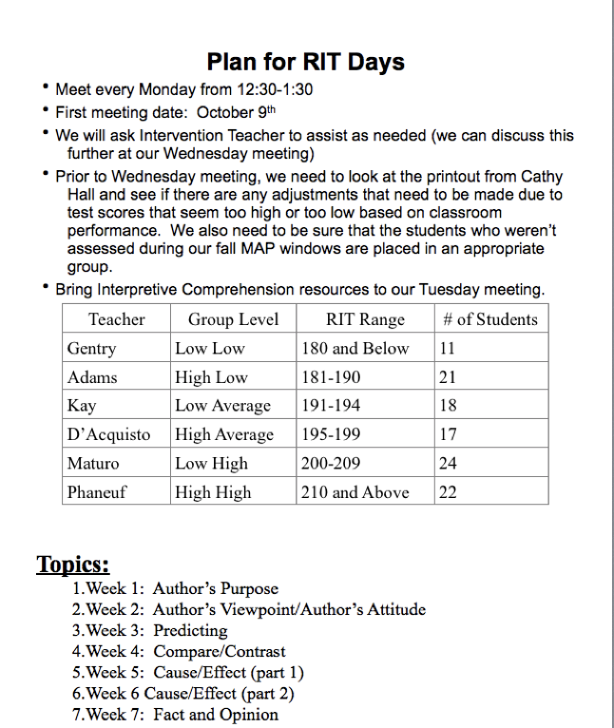

 **First Grade Reading Goal Sheet**

Name _____________________________

|  |  |  |  |  |  |  |
| --- | --- | --- | --- | --- | --- | --- |
| **Date** | **August** | **October** | **December** | **February** | **March** | **May** |
| **Level** |  |  |  |  |  |  |
| **Growth** |  |  |  |  |  |  |

**Benchmark 20**

**I will work on the strategies that are highlighted (more on the back):**

**Cross Check**

If your child reads a word incorrectly ask- “Does the word you are reading match the picture or letters written? Does it sound right? Does it make sense?”

**Check for Understanding**

Stop 3-4 times while reading to ask- “**Who** is the story about and **what** just happened?”

**Back Up and Reread**

If your child is unable to answer the “who” and “what” ask- “What does a good reader do when it doesn’t make sense?” STOP, BACK UP and REREAD!

**Know Many Words by Heart**

Your child may bring home a list of sight words to review. Your child should be able to read these words quickly. The following are activities you can do at home:

-Have your child play detective and find these words in their reading books.

-Create a sight word Memory or Go Fish game using index cards.

-Use old newspapers or magazines and have your child highlight their sight words.

-Write sight words on a piece of paper, cut the letters apart and see if your child can put them back together.

**Practice and Read Again**

If your child reads slowly and/or lacks expression have your child reread a book or a paragraph several times until they read it smoothly. Model what fluent reading sounds like by reading to your child.

**Blending/Stretching Sounds**

Sound blending is the ability to build words from individual sounds by blending the sounds together in sequence. This is essential in reading. In order to read words, students must know sounds for each letter and blend sounds together to make a word. When reading and blending sounds together, encourage your child to “Say each letter sound as you stretch them out (like a rubber band), then put them together and say it fast (h…e…l…p - help).”

**To help your child, write simple three letter words a piece of paper (ran, fit, pen…) for your child to read.

**Chunking Letters/Sounds**

When reading encourage your child to watch for familiar word patterns called chunks (c**ar**, fi**sh**, st**ay**, m**ee**t, **in**side…). When reading/decoding an unknown word, we want your child to be able to find familiar chunks/word parts. Have your child use his/her finger to frame the chunks found in the word and then move on to reading the rest of the word.

**To help your child practice, play “I Spy” when reading. For example, when looking at the word sand, you would say, “In this word I spy the word and.”

**Flip the Sound**

When reading a long vowel word, your child may say the short vowel sound. Example: If the word “cake” is in the story, your child may say “cak”. That does not make sense. So then, he/she needs to “flip the sound” saying the long vowel sound “cake”.

**Listen for Interesting Words**

We want children to be excited about learn new words! When you come across a word that your child does not know explain what the word means. You could also keep a notebook to write down interesting words that you and your child come across when reading.

**Play with Rhyming Words**

Students can see a work like “cat” and know the words, “mat, hat, bat…”

**Name the Characters**

Who is this story about?

**Name the Setting**

Where/when does the story take place?

**Name the Problem & Solution**

What is the problem? How is the problem solved/what is the solution?

**Other**

__________________________________________________________________________

____________________________________________________________________________

**\*\*Don’t forget to praise your child when you see them using strategies: “I like the way you…!”**

**In order to reach my goal, I will:**

* **Do my best reading when in my reading group and during Daily 5**
* **Practice reading my books every day to at least one adult**

**Student ____________________________ Teacher ____________________________**

**Parent _____________________________ Principal ___________________________**

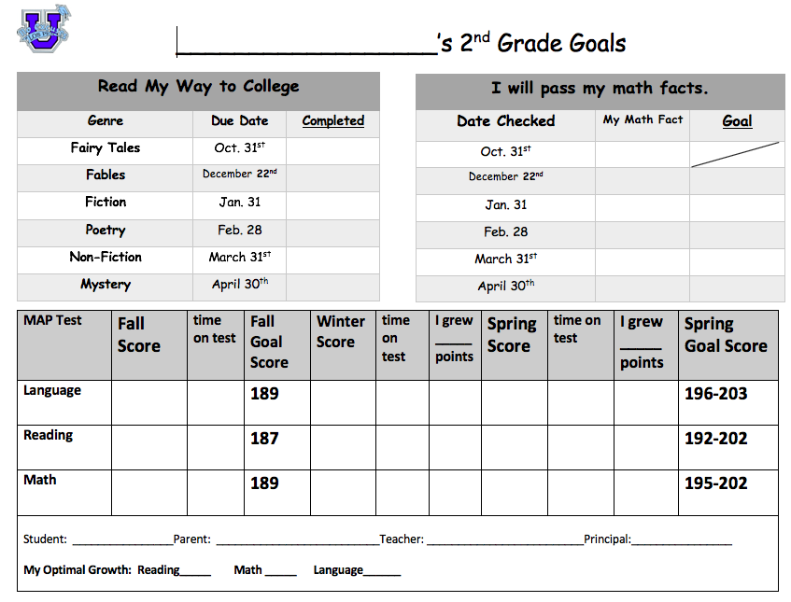

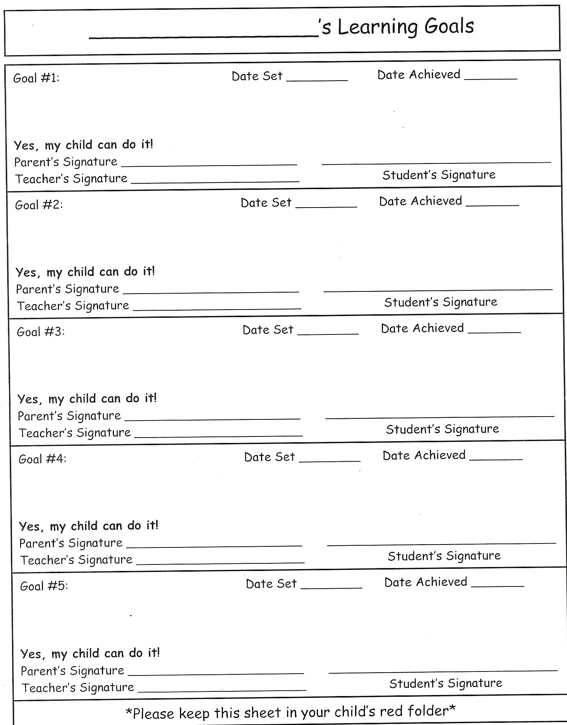

# NEULOGO2No Excuses University

## **Personal Academic Goal Sheet**

Name:

Subject:

Goal:

|  |  |  |  |
| --- | --- | --- | --- |
|  | **September** | **February** | **Growth** |
| **Goal Area Score** |  |  |  |
| **Overall Score** |  |  |  |

**Specific Learning Needed:**

* ____________________________________________________________________________________________________________________________________
* ____________________________________________________________________________________________________________________________________
* ____________________________________________________________________________________________________________________________________
* ____________________________________________________________________________________________________________________________________

**In order to reach my goal, I will:**

* __________________________________________________________________
* __________________________________________________________________
* __________________________________________________________________
* __________________________________________________________________



Student Signature

Teacher Signature

Principal Signature

Parent Signature

Personal Teaching Goals for My “Extreme Academic Makeover”

Name: ___________________

I include the following activities in my instructional planning:

|  |  |  |  |
| --- | --- | --- | --- |
|  | Always | Sometimes | Never |
| Use assessments “for” learning |  |  |  |
| Create class goals |  |  |  |
| Create individual student goals |  |  |  |
| Collaborate with my grade level team to differentiate |  |  |  |

My Personal Improvement Goal: _______________________________________________

_______________________________________________________________________

Action Steps:

* __________________________________________________________________
* __________________________________________________________________
* __________________________________________________________________
* __________________________________________________________________

Help and Resources needed:

* __________________________________________________________________
* __________________________________________________________________
* __________________________________________________________________
* __________________________________________________________________

Timeline:

I will begin on: __________________________

Completion date: ________________________